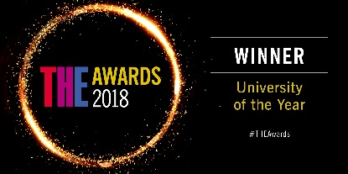
History Taster day 01/07/19

09.00am Arrival
Silberrad Student Centre Reception

09.30am Welcome and Introduction to the History department
10.00am Shirley Wang & Acadmeic
Location: 5S.4.19

10.00am Early Modern History: Fathers of Dracula
11.00am Dr Thomas Freeman
Location: 5S.4.19
People commonly believe that the concept of a vampire is one of great antiquity, rooted in timeless folklore. While concepts of creatures that drink blood are relatively ubiquitous and go back to the ancient world, vampires as we imagine them today—aristocratic, beautiful and, above all, sublimations of sexual desire—are exclusively products of nineteenth-century European literature. In this session we will look at the ways that the image of vampires evolved over the century, culminating in Bram Stoker’s Dracula, as well as the reasons behind this development and behind the astonishing popularity of the new genre.

11.00am Campus Tour or Accommodation talk
11.45am Location: 1N1.4.1

11.45am Personal statement workshop
12.30pm Location: 1N1.4.1

12.30pm Lunch
12.55pm

13.00pm Modern History: Revolution and Democracy in Germany 1918-1919
14.00pm Dr Nadine Rossol
Location: 5S.4.19
100 years ago Germany established its first republican democracy. This meant new political rights and liberties through a new constitution. Germans could watch and experience a new political system in the making. We will examine what Germans thought and felt about these fundamental changes. We will find out how they tried to shape their country's future in a time period of uncertainty but also one of promise.

14.00pm Depart

Yvonne Emannuels 01206872800

